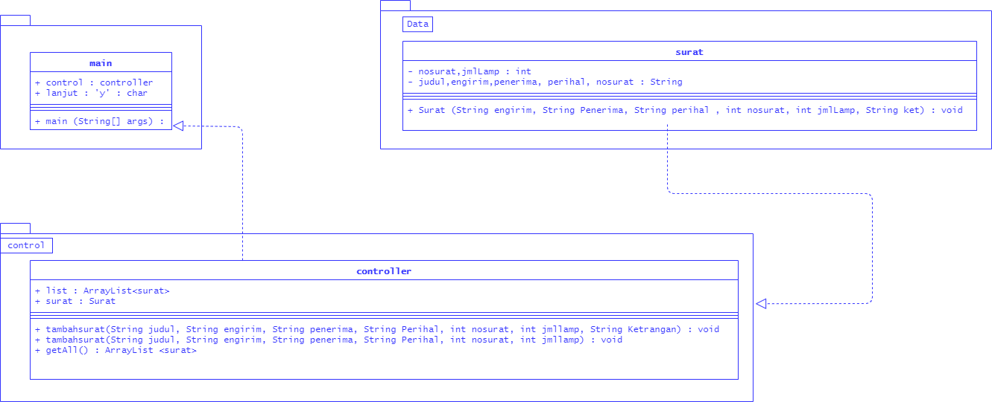

Keterangan Source Code :

---------------------------------------------------------------------------------------------------------------------------------------------------------------------------------------------------------------------------------------------------------------------------------------------------------------------------------------------------------------------------------------------------------------------------------------------------------------------------------------------------------------------------------------------------------------------------------------------------------------------------------------------------------------------------------------------------------------------------------------------------------------------------------------------------------------------------------------------------------------------------------------------------------------------------------------------------------------------------------------------------------------------------------------------------------------------------------------------------------------------------------

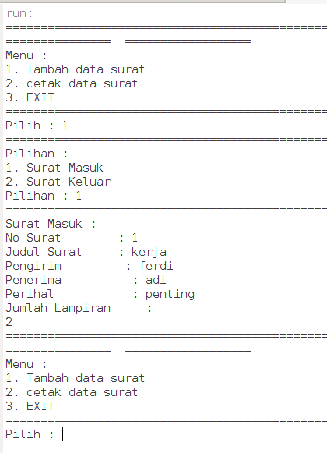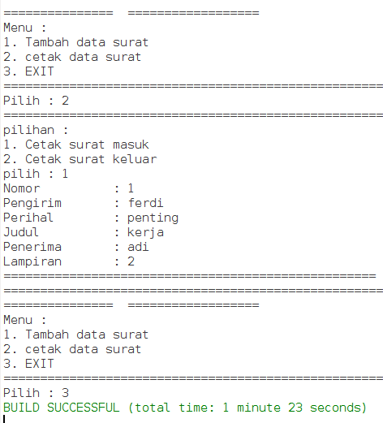

Keterangan Source Code :

---------------------------------------------------------------------------------------------------------------------------------------------------------------------------------------------------------------------------------------------------------------------------------------------------------------------------------------------------------------------------------------------------------------------------------------------------------------------------------------------------------------------------------------------------------------------------------------------------------------------------------------------------------------------------------------------------------------------------------------------------------------------------------------------------------------------------------------------------------------------------------------------------------------------------------------------------------------------------------------------------------------------------------------------------------------------------------------------------------------------------------------------------------------------------------------------------------------------------------------------------------------------------------------------------------------------------------------